## horizontal line

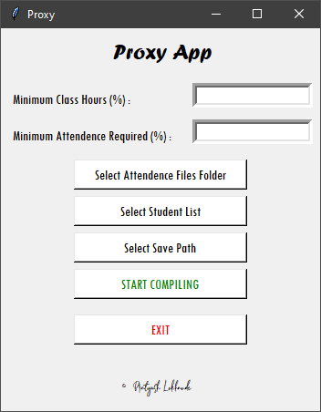

Proxy App

Generate Attendance reports instantly!

**─**

Pratyush Lokhande

2nd Year UG Student

Computer Science and Engineering

MANIT Bhopal (M.P.)

# Overview

Proxy App is an application specially designed to make the attendance monitoring process automated, resulting in saving loads of time. This application is developed with a motive to help teachers to generate attendance reports automated way with the greatest efficiency.

# Goals

1. Cut down the time required in making attendance reports manually
2. Using technology to make the process automated, thus saving time and increasing efficiency rate

# Specifications

It is a python based application solely developed for Windows operating systems. It does not require any special add-ons. Just the app and the required files and boom you are ready to crack out reports within seconds.

## Problem Statement

1. As the lectures are being conducted online, teachers have to put in a lot of effort in conducting classes and the same goes for making attendance reports as well.
2. The attendance monitoring task is time-consuming as a result teachers drop the attendance criteria, and students get a very big reason for not attending classes.

# Milestones

## Cutting Manual Process Time

The manual work for the attendance reports has been cut off by this application and the reports are generated within seconds thus saving a lot of time.

## Increase in number of Attendees

The automated way will motivate teachers to keep up with the 75% attendance criteria and thus will increase the number of students attending the classes.

# User Reference

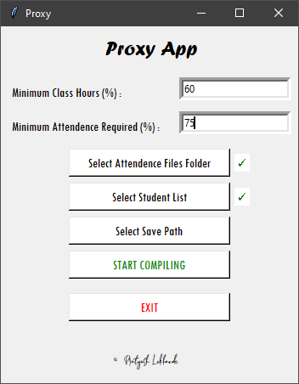

| **Minimum Class Hours (%)** | Percentage time student should be present in a class to mark his attendance as present |
| --- | --- |
| **Minimum Attendance Required (%)** | Minimum % attendance required to be safe from getting detention |
| **Select Attendance Files Folder** | This will the folder containing all the attendee sheets downloaded from the teams’ app |
| **Select Student List** | This is an excel file containing students scholar number and name |
| **Select Save Path** | The path where users want to save the output files |
| **START COMPILING** | After all of the entries are entered, click this button to start the compilation process |
| **EXIT** | Click this button to exit out from the application midway |

## After successful/unsuccessful compilation, a notification window will pop up as shown below :

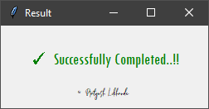

## **Sample Datasets**

1. Attendance File

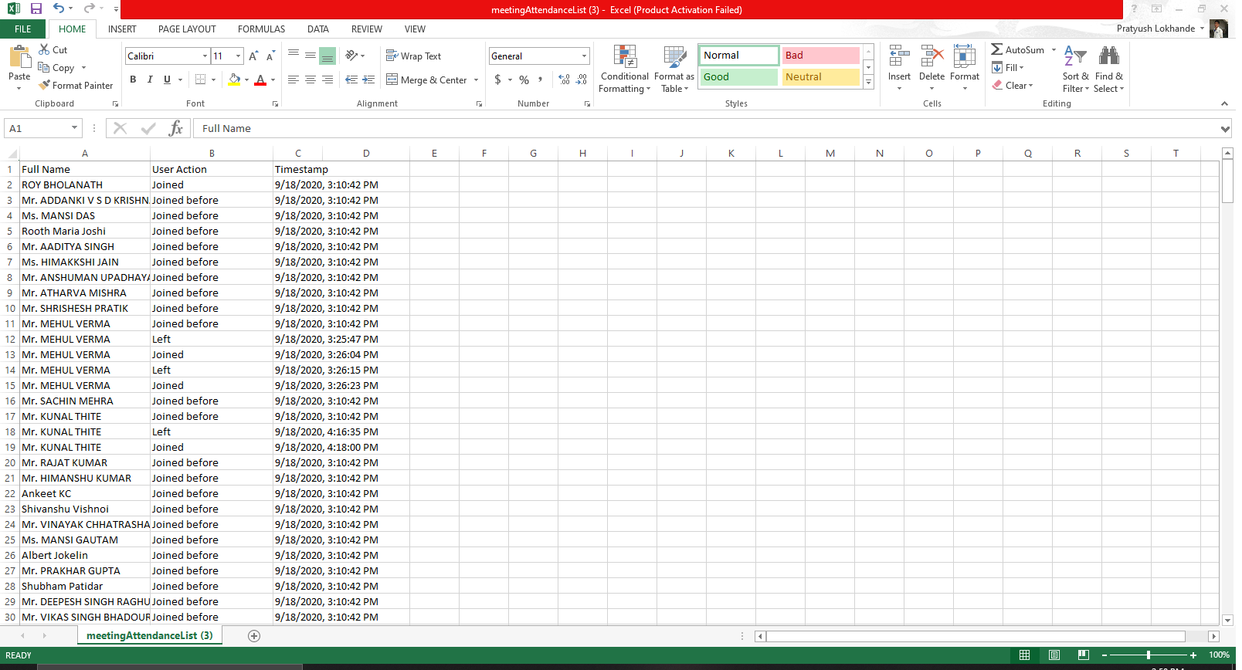

1. Student List

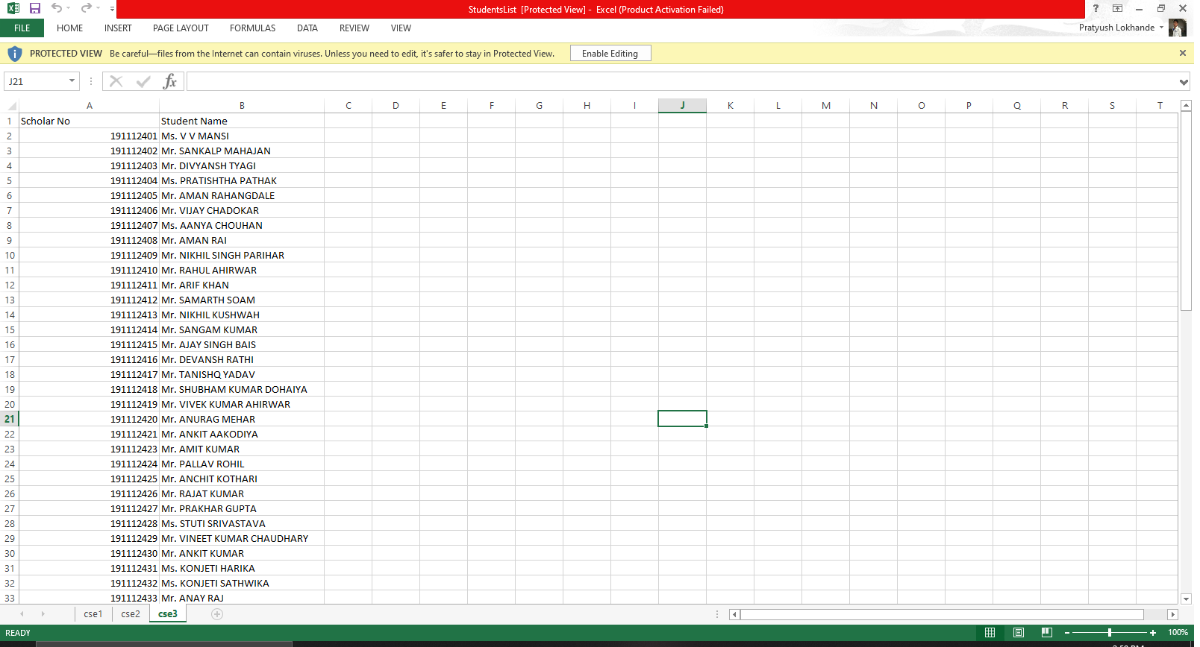

1. Output File

